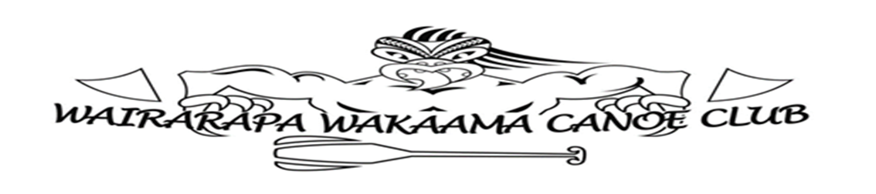

TE KARU O TE IKA – Ki te hoe and Steered by Te Wananga o Aotearoa
Saturday 22nd – Sunday 23rd January 2022

COVID-19
As at 7 November 2021, under the current restrictions, no event with more than 100 participants
is able to go ahead. The following measures have been put in place, in order to go ahead with
some or all of our regional sprint events:

W6 events:
- All paddlers, club representatives, volunteers and supporters 12 years and older must be fully vaccinated.
- We will ask each person attending to fill in a waiver form, and if asked, to provide proof of vaccination.
- In any case, the W6 and W12 events on 22nd and 23rd January 2022. will only be able to go ahead if we remain in orange.

As the Covid-19 levels and restrictions are an ever-changing landscape, we will keep you
informed of any changes, event cancellations, or additional requirements.

Key dates
- 23rd December 2021 Entries Open Online.
- 17 January 2022: Entries close for W6/W12
- 18th January 2022 Rosters close for W6/W12
- The lane draw will be made available by Wednesday 20th January 2022.
- If the event, or any one of the two days of racing, is postponed due to adverse weather conditions, Wairarapa Waka Ama Canoe CLub will advise paddlers via facebook page and NZ Waka Ama Website on the day before by 1pm.

Entry process
- All entries are to be done online via your club.
- Monday 17th January 2022. By this date, all entries have to be confirmed in the online entry system.
- Roster closes for W6/W12 on Tuesday 18th January 2022. By this date, clubs have to confirm all paddlers that race in each W6 and W12 team. In order to assign paddlers to each team, all paddlers have to be affiliated.
- Late entries may be permitted only if workload allows but will incur a late fee and are subject to lane availability.
- Each team must have a unique name; clubs must NOT use numbers in team names when making entries.
- Entries can be viewed on www.wakaama.co.nz go to the race notice.
- The event is open for entries from clubs outside the region.
- Clubs will be need to pay no later than Monday 17th January 2022. No cash will be accepted.
- There will be no refunds or entry fee reduction for withdrawals of entries or no-shows for each category after the specified entry close dates.

Event Schedule for W6/W12
Saturday 22nd January 2022
6.30am | Volunteers meet: event preparation commences, pick up resources for officials
7.30am | Registration Opens
8.30am | Karakia, Race and Safety briefting for all clubs and competetiors
8.45am | Race Calls start
8.50am | Starter boat and all official stations ready
9.00am | Racing Starts
4.00pm | Racing Concluded for the day

Sunday 23rd January 2022
6.30am | Volunteers meet: event preparation commences, pick up resources for officials
7.30am | Registration Opens
8.30am | Karakia, Race and Safety briefting for all clubs and competetiors
8.45am | Race Calls start
8.50am | Starter boat and all official stations ready
9.00am | Racing Starts
4.00pm | Racing Concluded for the day

Volunteers
- In order to run the event, we require a number of volunteers on a variety of official stations and in different roles, including setting-up / cleaning-up, registration, loading bay, flag boat, aligner, and finish line.
- If you are able to help on race day (either as a head official or as an assistant), please contact wairarapawakaama@outlook.com . We will also contact clubs directly.
- All volunteers must be fully vaccinated.

